

ASSET VERIFICATION AND RECORDING TOOL KIT


Plot 31, Bukoto Street
P.O Box 7657, Kampala, Uganda
+256 (0) 39 2000216/0772525235
email: cpa@cpa.ug

www.cpa.com

August to September 2026

VERIFICATION DETAILS

NAME OF THE REGION: | WESTERN REGION
SUB-REGION: | TOORO
Name of Local Government | KYENJOJO DISTRICT LOCAL GOVERNMENT
VERIFIER PARTICULARS
Full name | KATO CHARLES
Contact/ email and Telephone | 0755790124  Katoc560@gmail.com
Supervisor/ Sub team leader
Name | Prof. MBONIGABA DEPAUL
Contact | 0788483159
Date of submission | 01/09/2026

HEALTH CENTRES
INFORMANT INTERVIEW/DISCUSSION GUIDE (INCHARGE OR RESPONSIBLE PERSON)

Name of Health Centre: KATARAZA HC III

1a | Does the Facility have a record of all assets provided under UgIFT.  (Obtain a record and verify if it has the costs and numbers supplied | The facility had a list of items received, with no costs for each item
1b | If Not ask how many were supplied and when.

2 | How does this facility Maintain (repair/service/replace) the assets provided under Ugift

The facility facilitates minor repairs using a dedicated budget on the PHC funds it receives every quarter

3 | Does the facility take regular record about functionality/ or breakdown of the assets provided? | No

The facility did not have records, or lists indicating which items are functional or broken down

4 | How has the UgIFT support helped in service delivery in the area, any issues, challenges and any recommendations for better program implementation.

The construction of kataraza hc iii greatly reduced the long distance that pregnant mothers would walk to health centers which was about 40km.
The health workers stressed the fact that they did not know some of the equipment provided to them and recommended they should be reoriented on how to use this equipment.

PROCEED TO VERIFICATION AFTER THIS DISCUSSION

Health centre checklist

NAME OF LG: KYENJOJO DISTRICT NAME OF HEALTH FACILITY: KATALAZA HC III

Equipment/ Item | Department | Asset Number | Item  Description | Life in Months | Tag Number (engrave no.) | Date Of Purchase | Date Placed in Service | Recoverable cost | Cost | Acc Dep Cost | Net Book Value | Ytd Deprn | Equipment status | Remarks
B.P. Machine, Digital | health |  | sinoheart, model BA-801 sionocare bp machine |  | Not engraved |  | 6/10/2023 |  |  |  |  |  | Functional
B.P. Machine (Aneroid wall mounted) | health |  | BP machine (aneroid wall mounted, Navy blue in colour novaphon model |  | Not engraved |  | 6/10/2023 |  |  |  |  |  | Functional
 | health |  | BP machine (aneroid wall mounted, Navy blue in colour novaphon model |  | Not engraved |  | 6/10/2023 |  |  |  |  |  | Not functional | In the store
Autoclave 20 Liters., Duo Operated | health | AU2300 | Autoclave, external heated, 20liters |  | Not engraved |  | 6/10/2023 |  |  |  |  |  | functional
Bowl, Kick | Health |  | 1 bowl kick |  | Not engraved |  | 6/10/2023 |  |  |  |  |  | Not functional | Item in the store
Bowl Stand | Health |  | Stainless steel movable |  | Not engraved |  | 6/10/2023 |  |  |  |  |  | functional
 | health |  | Stainless steel movable |  |  |  | 6/10/2023 |  |  |  |  |  | functional
Counting chamber Neubauer- Improved | Health |  | Rectangular shaped apparatus with droppers |  | Not engraved |  | 6/10/2023 |  |  |  |  |  | Not functional
 | health |  | Rectangular shaped apparatus with droppers |  | Not engraved |  | 6/10/2023 |  |  |  |  |  | Not functional
Cupboard Steel, Lockable | Health
 | Health |  | 1 cupboard steel with transparent glass, lockable (grey) |  | Not |  | 6/10/2023 |  |  |  |  |  | Functional
 | Health |  | 1 cupboard steel with transparent glass, lockable (grey) |  | Not engraved |  | 6/10/2023 |  |  |  |  |  | functional
 | Health |  | 1 cupboard steel with transparent glass, lockable (grey) |  | Not engraved |  | 6/10/2023 |  |  |  |  |  | functional
Drip Stand
 | Health |  | Drip stand, MK-ISO, SN MM220210C01 |  | Not engraved |  | 6/10/2023 |  |  |  |  |  | Not functional
 | Health |  | Drip stand, MK-ISO, SN MM220210C01 |  | Not engraved |  | 6/10/2023 |  |  |  |  |  | Not functional
 | Health |  | Drip stand, MK-ISO, SN MM220210C01 |  | Not engraved |  | 6/10/2023 |  |  |  |  |  | Not functional
ESR Stand | health |  | 1 ESR was available with sedimentation tubes |  | Not engraved |  | 6/10/2023 |  |  |  |  |  | functional
Examination Couch
 | Health |  | Examination couch metallic with a mattress |  | Not engraved |  | 6/10/2023 |  |  |  |  |  | functional
 | Health |  | Examination couch metallic with a mattress |  | Not engraved |  | 6/10/2023 |  |  |  |  |  | functional
Examination light,LED | health |  | LED examination light |  | Not engraved |  | 6/10/2023 |  |  |  |  |  | functional
 | Health |  | LED examination light |  | Not engraved |  | 6/10/2023 |  |  |  |  |  | functional
Glucometer | health |  | A Yuwell glucometer, SN: B25070000104 |  | NOT ENGRAVED |  | 6/10/2023 |  |  |  |  |  | Not functional
Haemoglobin Meter, Digital | health
 | Health |  | Haemoglobin Meter, Digital |  | Not engraved |  | 6/10/2023 |  |  |  |  |  | Not functional
 | Health |  | Haemoglobin Meter, Digital |  | Not engraved |  | 6/10/2023 |  |  |  |  |  | Not functional
Height Meter
 | Health |  | 1 height meter |  | Not engraved |  | 6/10/2023 |  |  |  |  |  | Functional
Instrument Trolley
 | health |  | 1 instrument trolly |  | Not engraved |  | 6/10/2023 |  |  |  |  |  | Functional
 | health |  | 1 instrument trolly |  | Not engraved |  | 6/10/2023 |  |  |  |  |  | Functional
Microscope Binocular | health |  | 1 microscope binocular |  | Not engraved |  | 6/10/2023 |  |  |  |  |  | Functional
Otoscope | health |  | 1 otoscope |  | Not engraved |  | 6/10/2023 |  |  |  |  |  | Functional
Patient Screen | health |  |  |  |  |  | 6/10/2023
 | health |  | 1 patient screen, super care model TS-19 |  | Not engraved |  | 6/10/2023 |  |  |  |  |  | Not functional
 | health |  | 1 patient screen, metallic, blue in colour, movable |  | Not engraved |  | 6/10/2023 |  |  |  |  |  | Functional
 | health |  | 1 patient screen |  | Not engraved |  | 6/10/2023 |  |  |  |  |  | Functional
 | health |  | 1 patient screen |  | Not engraved |  | 6/10/2023 |  |  |  |  |  | Functional
 | health |  | 1 patient screen |  | Not engraved |  | 6/10/2023 |  |  |  |  |  | Functional
 | health |  | 1 patient screen |  | Not engraved |  | 6/10/2023 |  |  |  |  |  | Functional
 | health |  | 1 patient screen |  | Not engraved |  | 6/10/2023 |  |  |  |  |  | Not functional | Items in the store
 | health |  | 1 patient screen |  | Not engraved |  | 6/10/2023 |  |  |  |  |  | Not functional | Items in the store
Patient Trolley | Health |  | 1 patient trolley of casp |  | Not engraved |  | 6/10/2023 |  |  |  |  |  | functional
Refrigerator, Basic | Health |  | 1 refrigerator basic, Hisense brand | 18 months | Not engraved |  | 6/10/2023 |  |  |  |  |  | Functional
Stethoscope | Health |  | stethoscope |  | Not engraved |  | 6/10/2023 |  |  |  |  |  | Functional
 | Health |  | stethoscope |  | Not engraved |  | 6/10/2023 |  |  |  |  |  | Not functional
 | Health |  | stethoscope |  | Not engraved |  | 6/10/2023 |  |  |  |  |  | Not functional
 | Health |  | stethoscope |  | Not engraved |  | 6/10/2023 |  |  |  |  |  | Not functional
Stopwatch | Health |  | 1 stopwatch |  | Not engraved |  | 6/10/2023 |  |  |  |  |  | functional
Stretcher
 | Health |  | 1 stretcher, movable |  | Not engraved |  | 6/10/2023 |  |  |  |  |  | functional
Stove, Gas | health |  | STOVE GAS, Sn: HU-102 |  | Not engraved |  | 6/10/2023 |  |  |  |  |  | Not Functional | Item in the store
Weighing Scale with Height Meter, Adult | health |  | 1 weighing scale with height measure |  | Not engraved |  | 6/10/2023 |  |  |  |  |  | Functional
 | Health |  | 1 weighing scale with height measure |  | Not engraved |  | 6/10/2023 |  |  |  |  |  | functional
 | health |  | 1 weighing scale with height measure |  | Not engraved |  | 6/10/2023 |  |  |  |  |  | Functional
 | Health |  | 1 weighing scale with height measure |  | Not engraved |  | 6/10/2023 |  |  |  |  |  | functional
Weighing Scale, Infant | Health |  | Hanging weighing scale foe infants, SN: BS-50 |  | Not engraved |  | 6/10/2023 |  |  |  |  |  | functional
 | Health |  | Hanging weighing scale foe infants, SN: BS-50 |  | NOT ENGRAVED |  | 6/10/2023 |  |  |  |  |  | NOT FUNCTIONAL | Still in the store
Weighing Scale, Toddler | Health |  | 1 weighing scale toddler, KUANYI MODEL, BS-50 |  | Not engraved |  | 6/10/2023 |  |  |  |  |  | Functional in the maternity ward
 | Health |  | 1 weighing scale toddler, KUANYI MODEL, BS-50 |  | Not engraved |  | 6/10/2023 |  |  |  |  |  | Functional in the maternity ward
Wheelchair | Health |  | 1 wheelchair |  | Not engraved |  | 6/10/2023
 | Health |  | 1 wheelchair |  | Not engraved |  | 6/10/2023 |  |  |  |  |  | Not functional
Audio Visual Equipment | Health
Medical Waste Bin | health
 | Health |  | Stainless steel bins |  | Not engraved |  | 6/10/2023 |  |  |  |  |  | Functional
 | Health |  | Stainless steel bins |  | Not engraved |  | 6/10/2023 |  |  |  |  |  | Functional
 | Health |  | Medical waste bins |  | Not engraved |  | 6/10/2023 |  |  |  |  |  | Functional
 | Health |  | Medical waste bins |  | Not engraved |  | 6/10/2023 |  |  |  |  |  | Functional
 | Health |  | Medical waste bins |  | Not engraved |  | 6/10/2023 |  |  |  |  |  | functional
Wall Clock |  |  |  |  |  |  | 6/10/2023
 | Health |  | Wall clock |  | Not engraved |  | 6/10/2023 |  |  |  |  |  | functional
 | Health |  | Wall clock |  | Not engraved |  | 6/10/2023 |  |  |  |  |  | functional
 | Health |  | Wall clock |  | Not engraved |  | 6/10/2023 |  |  |  |  |  | Functional
 | Health |  | Wall clock |  | Not engraved |  | 6/10/2023 |  |  |  |  |  | Functional
Diagnostic Equipment Set for MCH | Health | SL304 | Full diagnostic set consisting of all equipment (full medical package) |  | Not engraved |  | 6/10/2023 |  |  |  |  |  | Not functional
 | Health | SL304 | Full diagnostic set consisting of all equipment (full medical package) |  | NOT ENGRAVED |  | 6/10/2023 |  |  |  |  |  | NOT FUNCTIONAL
 | Health | SL304 | Full diagnostic set consisting of all equipment (full medical package) |  | NOT ENGRAVED |  | 6/10/2023 |  |  |  |  |  | NOT FUNCTIONAL
Diagnostic Equipment Set for OPD | Health | SL304 |  |  |  |  | 6/10/2023
 | Health | SL304 | 1 diagnostic equipment set |  | Not engraved |  | 6/10/2023 |  |  |  |  |  | Not functional
 | Health | SL304 | 1 diagnostic equipment set |  | Not engraved |  | 6/10/2023 |  |  |  |  |  | Not functional
Glassware Set, Laboratory, Basic | Health |  | 1 glass ware set` |  | Not engraved |  | 6/10/2023 |  |  |  |  |  | Functional
 | Health |  | 1 glass ware set` |  | Not engraved |  | 6/10/2023 |  |  |  |  |  | Functional
Hollow Ware Set, Treatment | Health |  | 1 hollow ware set, full set |  | Not engraved |  | 6/10/2023 |  |  |  |  |  | Not functional
 | Health | SL304 | 1 hollow ware set, full set |  | Not engraved |  | 6/10/2023 |  |  |  |  |  | Not functional
Instrument Set, Dressing | Health | SL304 | 1 Set consists of forceps, scissors, bowls, lotion, kidney, instrument container s/s with cover |  | Not engraved |  | 6/10/2023 |  |  |  |  |  | Not functional
 | Health | SL304 | 1 Set consists of forceps, scissors, bowls, lotion, kidney, instrument container s/s with cover. |  | Not engraved |  | 6/10/2023 |  |  |  |  |  | Functional
Instrument Set, Basic ENT | Health | SL304 | 1 Set consists of forceps, scissors, bowls, lotion, kidney, instrument container s/s with cover. |  | Not engraved |  | 6/10/2023 |  |  |  |  |  | Functional
Instrument Set, Suture | Health | SL304 | 1 Set consists of forceps, scissors, bowls, lotion, kidney, instrument container s/s with cover. |  | Not engraved |  | 6/10/2023 |  |  |  |  |  | Functional
 | Health | SL304 | 1 Set consists of forceps, scissors, bowls, lotion, kidney, instrument container s/s with cover. |  | Not engraved |  | 6/10/2023 |  |  |  |  |  | Functional
 | Health | SL304 | 1 Set consists of forceps, scissors, bowls, lotion, kidney, instrument container s/s with cover. |  | Not engraved |  | 6/10/2023 |  |  |  |  |  | Functional
Pulse Oximeter, Handheld | Health |  |  |  |  |  | 6/10/2023
 | Health |  | 1 Pulse oximeter, handheld |  | Not engraved |  | 6/10/2023 |  |  |  |  |  | Functional
 | Health |  | 1 Pulse oximeter, handheld |  | Not engraved |  | 6/10/2023 |  |  |  |  |  | Not functional
Bed, Adult Patient with Mattress | Health |  | Adult beds with metallic mattresses |  | Not engraved |  | 6/10/2023 |  |  |  |  |  | functional
 | Health |  | Adult beds with metallic mattresses |  | Not engraved |  | 6/10/2023 |  |  |  |  |  | Functional
 | Health |  | Adult beds with metallic mattresses |  | Not engraved |  | 6/10/2023 |  |  |  |  |  | Functional
 | Health |  | Adult beds with metallic mattresses |  | Not engraved |  | 6/10/2023 |  |  |  |  |  | Functional
 | Health |  | Adult beds with metallic mattresses |  | Not engraved |  | 6/10/2023 |  |  |  |  |  | Functional
 | Health |  | Adult beds with metallic mattresses |  | Not engraved |  | 6/10/2023 |  |  |  |  |  | Functional
 | Health |  | Adult beds with metallic mattresses |  | Not engraved |  | 6/10/2023 |  |  |  |  |  | Functional
 | Health |  | Adult beds with metallic mattresses |  | Not engraved |  | 6/10/2023 |  |  |  |  |  | Functional
 | Health |  | Adult beds with metallic mattresses |  | Not engraved |  | 6/10/2023 |  |  |  |  |  | Functional
 | Health |  | Adult beds with metallic mattresses |  | Not engraved |  | 6/10/2023 |  |  |  |  |  | Functional
 | Health |  | Adult beds with metallic mattresses |  | Not engraved |  | 6/10/2023 |  |  |  |  |  | Functional
 | Health |  | Adult beds with metallic mattresses |  | Not engraved |  | 6/10/2023 |  |  |  |  |  | Functional
 | Health |  | Adult beds with metallic mattresses |  | Not engraved |  | 6/10/2023 |  |  |  |  |  | Functional
Bed, Pediatric Patient, With Mattress |  |  |  |  |  |  | 6/10/2023
 | Health |  | Pediatric bed with metallic mattresses |  | Not engraved |  | 6/10/2023 |  |  |  |  |  | Functional
 | Health |  | pediatrics bed with mattress metallic |  | Not engraved |  | 6/10/2023 |  |  |  |  |  | Functional
 | Health |  | pediatrics bed with mattress metallic |  | Not engraved |  | 6/10/2023 |  |  |  |  |  | Functional
 | Health |  | pediatric beds with mattresses metallic |  | Not engraved |  | 6/10/2023 |  |  |  |  |  | Functional
Bedside Locker | Health |  | Metallic bedside locker, steel |  | KATR-UGIFT |  | 6/10/2023 |  |  |  |  |  | Functional
 | Health |  | Metallic bedside locker, steel |  | KATR-UGIFT |  | 6/10/2023 |  |  |  |  |  | Functional
 | health |  | Metallic bedside lockers, steel |  | KATR-UGIFT |  | 6/10/2023 |  |  |  |  |  | functional
 | Health |  | Metallic bedside locker, steel |  | KATR-UGIFT |  | 6/10/2023 |  |  |  |  |  | Functional
 | health |  | Metallic bedside lockers, steel |  | KATR-UGIFT |  | 6/10/2023 |  |  |  |  |  | functional
 | Health |  | Metallic bedside locker, steel |  | KATR-UGIFT |  | 6/10/2023 |  |  |  |  |  | Functional
 | health |  | Metallic bedside lockers, steel |  | KATR-UGIFT |  | 6/10/2023 |  |  |  |  |  | functional
 | Health |  | Metallic bedside locker, steel |  | KATR-UGIFT |  | 6/10/2023 |  |  |  |  |  | Functional
 | health |  | Metallic bedside lockers, steel |  | KATR-UGIFT |  | 6/10/2023 |  |  |  |  |  | functional
 | Health |  | Metallic bedside locker, steel |  | KATR-UGIFT |  | 6/10/2023 |  |  |  |  |  | Functional
 | health |  | Metallic bedside lockers, steel |  | KATR-UGIFT |  | 6/10/2023 |  |  |  |  |  | functional
Cupboard, Instrument | health |  | 1 cupboard steel lockable |  | Not engraved |  | 6/10/2023 |  |  |  |  |  | functional
 |  |  | 1 cupboard steel lockable |  | Not engraved |  | 6/10/2023 |  |  |  |  |  | functional
Delivery Bed, Hydraulic Manual
Oxygen Therapy Apparatus, Mininum 45L cylinder | Health |  | 1 Oxygen cylinders of 49,8L 2, oxygen regulators (2), humidifier bottles (2) |  | Not engraved |  | 6/10/2023 |  |  |  |  |  | Not functional
 |  |  | 1 Oxygen cylinders of 49,8L 2, oxygen regulators (2), humidifier bottles (2) |  | Not engraved |  | 6/10/2023 |  |  |  |  |  | Not functional
Resuscitator Manual, Infant, with all Mask sizes | Health |  | 1 resuscitator manual |  | Not engraved |  | 6/10/2023 |  |  |  |  |  | Not functional
 | Health |  | 1 resuscitator manual |  | Not engraved |  | 6/10/2023 |  |  |  |  |  | Not functional
Resuscitator Manual, Adult, with all mask sizes | Health |  | 1 resuscitator manual, adult |  | Not engraved |  | 6/10/2023 |  |  |  |  |  | Not functional
 | Health |  | 1 resuscitator manual, adult |  | Not engraved |  | 6/10/2023 |  |  |  |  |  | Not functional
Suction Apparatus, (Electric) | Health |  | 1 suction apparatus, new hospivac brand |  | Not engraved |  | 6/10/2023 |  |  |  |  |  | Not functional
 | Health |  | 1 suction apparatus, electric |  | Not engraved |  | 6/10/2023 |  |  |  |  |  | Not functional
Nebulizer, Ultrasonic
 | Health |  | 1 nebulizer ultrasonic, long fian brand |  | Not engraved |  | 6/10/2023 |  |  |  |  |  | Not functional
Oxygen Concentrator, Duo Flow | Health |  | 1Oxygen concentrator |  | Not engraved |  | 6/10/2023 |  |  |  |  |  | functional
 | Health |  | 1 Oxygen concentrator |  | Not engraved |  | 6/10/2023 |  |  |  |  |  | functional
 | Health |  | 1 Oxygen concentrator |  | Not engraved |  | 6/10/2023 |  |  |  |  |  | functional
Bench
 | Health |  | 1 metallic vanished bench |  | Not engraved |  | 6/10/2023 |  |  |  |  |  | functional
 | Health |  | 1 metallic vanished bench |  | Not engraved |  | 6/10/2023 |  |  |  |  |  | functional
 | Health |  | 1 metallic vanished bench |  | Not engraved |  | 6/10/2023 |  |  |  |  |  | functional
 | Health |  | 1 metallic vanished bench |  | Not engraved |  | 6/10/2023 |  |  |  |  |  | functional
Disinfection Buckets
 | Health |  | 1 disinfection bucket |  | Not engraved |  | 6/10/2023 |  |  |  |  |  | functional
 | Health |  | 1 disinfection bucket |  | Not engraved |  | 6/10/2023 |  |  |  |  |  | functional
 | Health |  | 1 disinfection bucket |  | Not engraved |  | 6/10/2023 |  |  |  |  |  | functional
 | Health |  | 1 disinfection bucket |  | Not engraved |  | 6/10/2023 |  |  |  |  |  | functional
 | Health |  | 1 disinfection bucket |  | Not engraved |  | 6/10/2023 |  |  |  |  |  | functional
Baby Cot
 | Health |  | 1 baby cot |  | Not engraved |  | 6/10/2023 |  |  |  |  |  | functional
 | Health |  | 1 baby cot |  | Not engraved |  | 6/10/2023 |  |  |  |  |  | functional
 | Health |  | 1 baby cot |  | Not engraved |  | 6/10/2023 |  |  |  |  |  | Not functional
 | Health |  | 1 baby cot |  | Not engraved |  | 6/10/2023 |  |  |  |  |  | Not functional
Diagnostic Equipment Set for Ward | Health |  |  |  | Not engraved |  | 6/10/2023
 | health |  | 1 Set consists of:  Depressor, tongue, metal, hammer, percussion, reflex test, solid rubber head, ophthalmoscope, aneroid cuffs, stethoscope, tape, measure, cloth, thermometers, tuning forks, proctoscope, and syringes |  | Not engraved |  | 6/10/2023 |  |  |  |  |  | Functional
 | health |  | 1 Set consists of:  Depressor, tongue, metal, hammer, percussion, reflex test, solid rubber head, ophthalmoscope, aneroid cuffs, stethoscope, tape, measure, cloth, thermometers, tuning forks, proctoscope, and syringes |  | Not engraved |  | 6/10/2023 |  |  |  |  |  | Not Functional
Hollow Ware Set, Ward |  |  |  |  |  |  | 6/10/2023
 | Health |  | 1 hollow ware set consisting of a bed pan s/s with lid, bowl, urinal, lotions, forceps, instrument trays, jug measuring 1 litre, and kidney dishes |  | Not engraved |  | 6/10/2023 |  |  |  |  |  | Not functional
 | Health |  | 1 hollow ware set consisting of a bed pan s/s with lid, bowl, urinal, lotions, forceps, instrument trays, jug measuring 1 litre, and kidney dishes |  | Not engraved |  | 6/10/2023 |  |  |  |  |  | Not functional
Instrument Set, Delivery | Health |  | 1 set consisting of forceps, sponge holding, needle holder, scissors, speculum, bowls, kidney dish, and instrument container |  | Not engraved |  | 6/10/2023 |  |  |  |  |  | functional
 | Health |  | 1 set consisting of forceps, sponge holding, needle holder, scissors, speculum, bowls, kidney dish, and instrument container |  | Not engraved |  | 6/10/2023 |  |  |  |  |  | functional
Instrument Set, Stitch Removing | Health |  | 1 set, stitch removing consisting of forceps, sponge holding, scissors, bowls, lotion, and instrument containers |  | Not engraved |  | 6/10/2023 |  |  |  |  |  | functional
 | Health |  | 1 set, stitch removing consisting of forceps, sponge holding, scissors, bowls, lotion, and instrument containers |  | Not engraved |  | 6/10/2023 |  |  |  |  |  | functional
 | Health |  | 1 set, stitch removing consisting of forceps, sponge holding, scissors, bowls, lotion, and instrument containers |  | Not engraved |  | 6/10/2023 |  |  |  |  |  | functional
MVA Kit | Health |  | 1 MVA kit consisting of MVA Kit (double valve) forceps, sponge holding, manual valve aspirator, syringe aspirator 60CC, Karman cannulas with adaptor, speculum bowls, lotion |  | Not engraved |  | 6/10/2023 |  |  |  |  |  | functional
 | Health |  | 1 MVA kit consisting of MVA Kit (double valve) forceps, sponge holding, manual valve aspirator, syringe aspirator 60CC, Karman cannulas with adaptor, speculum bowls, lotion |  | Not engraved |  | 6/10/2023 |  |  |  |  |  | Not functional
 | Health |  | 1 MVA kit consisting of MVA Kit (double valve) forceps, sponge holding, manual valve aspirator, syringe aspirator 60CC, Karman cannulas with adaptor, speculum bowls, lotion |  | Not engraved |  | 6/10/2023 |  |  |  |  |  | Not functional
 | Health |  | 1 MVA kit consisting of MVA Kit (double valve) forceps, sponge holding, manual valve aspirator, syringe aspirator 60CC, Karman cannulas with adaptor, speculum bowls, lotion |  | Not engraved |  | 6/10/2023 |  |  |  |  |  | Not functional
 | Health |  | 1 MVA kit consisting of MVA Kit (double valve) forceps, sponge holding, manual valve aspirator, syringe aspirator 60CC, Karman cannulas with adaptor, speculum bowls, lotion |  | Not engraved |  | 6/10/2023 |  |  |  |  |  | Not functional
Stool, Laboratory
 | Health |  | 1 movable metallic stool |  | Not engraved |  | 6/10/2023 |  |  |  |  |  | functional
 | Health |  | 1 movable metallic stool |  | Not engraved |  | 6/10/2023 |  |  |  |  |  | functional
 | Health |  | 1 movable metallic stool |  | Not engraved |  | 6/10/2023 |  |  |  |  |  | functional
Penguin Sucker
 | Health |  | 1 penguin |  | Not engraved |  | 6/10/2023 |  |  |  |  |  | Functional
 | Health |  | 1 penguin |  | Not engraved |  | 6/10/2023 |  |  |  |  |  | Functional
 | Health |  | 1 penguin |  | Not engraved |  | 6/10/2023 |  |  |  |  |  | Functional
Fetoscope, Doppler | Health |  | 1 fetoscope |  | Not engraved |  | 6/10/2023 |  |  |  |  |  | functional
 | Health |  | 1 fetoscope |  | Not engraved |  | 6/10/2023 |  |  |  |  |  | functional
Bubble CPAP | Health |  | 1 bubble CPAP |  | Not engraved |  | 6/10/2023 |  |  |  |  |  | Not functional
 | Health |  | 1 bubble CPAP |  | Not engraved |  | 6/10/2023 |  |  |  |  |  | Not functional
Centrifuge (Electric) | Health |  | 1 Centrifuge, new |  | Not engraved |  | 6/10/2023 |  |  |  |  |  | Functional
 | Health |  | 1 Centrifuge, new |  | Not engraved |  | 6/10/2023 |  |  |  |  |  | Functional
Kangaroo Mother Care Chair | Health |  | 1 kangaroo mother care chair, green colour |  | Not engraved |  | 6/10/2023 |  |  |  |  |  | Functional
Radiant Infant Warmer | Health |  | 1 radiant infant warmer |  | Not engraved |  | 6/10/2023 |  |  |  |  |  | Functional
Haemoglobin Meter, Sahli | Health |  | 1 haemoglobin meter |  | Not engraved |  | 6/10/2023 |  |  |  |  |  | Not functional
 | Health |  | 1 haemoglobin meter |  | Not engraved |  | 6/10/2023 |  |  |  |  |  | Not functional
 | Health |  | 1 haemoglobin meter |  | Not engraved |  | 6/10/2023 |  |  |  |  |  | Not functional
Delivery Bed
 | Health |  | 1 Delivery bed |  | Not engraved |  | 6/10/2023 |  |  |  |  |  | Functional
Examination light
 | Health |  | 1 examination light |  | Not engraved |  | 6/10/2023 |  |  |  |  |  | functional
 | Health |  | 1 examination light |  | Not engraved |  | 6/10/2023 |  |  |  |  |  | functional
Instrument set, ENT Basic for HCIII
 | Health |  | Instrument set, ENT basic |  | Not engraved |  | 6/10/2023 |  |  |  |  |  | Not functional
 | Health |  | Instrument set, ENT basic |  | Not engraved |  | 6/10/2023 |  |  |  |  |  | Not functional
Bag Valve mask (Ambu Bag), Neonatal | Health |  | 1 ambu bag |  | Not engraved |  | 6/10/2023 |  |  |  |  |  | Not functional
Incubator
Office Chair | Health |  | Office chair, leather cushioned |  | Not engraved |  | 6/10/2023 |  |  |  |  |  | functional
 | health |  | Office chair, leather cushioned |  | Not engraved |  | 6/10/2023 |  |  |  |  |  | Functional
 | health |  | Office chair, leather cushioned |  | Not engraved |  | 6/10/2023 |  |  |  |  |  | Functional
 | health |  | Office chair, leather cushioned |  | Not engraved |  | 6/10/2023 |  |  |  |  |  | Functional
 | health |  | Office chair, leather cushioned |  | Not engraved |  | 6/10/2023 |  |  |  |  |  | Functional
 | health |  | Office chair, leather cushioned |  | Not engraved |  | 6/10/2023 |  |  |  |  |  | Functional
 | health |  | Office chair, leather cushioned |  | Not engraved |  | 6/10/2023 |  |  |  |  |  | Functional
Desk | Health |  | 1 desk, vanished |  | Not engraved |  | 6/10/2023 |  |  |  |  |  | Functional
 |  |  | 1 desk, vanished |  | Not engraved |  | 6/10/2023 |  |  |  |  |  | Functional
Table | Health |  | Table metallic frame of wooden top |  | Not engraved |  | 6/10/2023 |  |  |  |  |  | functional
 | Health |  | Table metallic frame of wooden top |  | Not engraved |  | 6/10/2023 |  |  |  |  |  | functional
 | Health |  | Table metallic frame of wooden top |  | Not engraved |  | 6/10/2023 |  |  |  |  |  | functional
Filing Cabinet |  |  |  |  |  |  | 6/10/2023
 | Health |  | Filling cabinet |  | KATR-UGIFT |  | 6/10/2023 |  |  |  |  |  | Functional
 | Health |  | Filing cabinet |  | KATR-UGIFT |  | 6/10/2023 |  |  |  |  |  | functional
 | Health |  | Filling cabinet |  | KATR-UGIFT |  | 6/10/2023 |  |  |  |  |  | Functional
 | Health |  | Filing cabinet |  | KATR-UGIFT |  | 6/10/2023 |  |  |  |  |  | functional
 | Health |  | Filing cabinet |  | KATR-UGIFT |  | 6/10/2023 |  |  |  |  |  | functional
Non-Residential Buildings | Health |  | MATERNITY BUILDING, with a placenta pit |  | Not engraved |  | 6/10/2023 |  |  |  |  |  | functional
 | Health |  | 1 four-stance lined pit latrine |  | Not engraved |  | 6/10/2023 |  |  |  |  |  | functional
 | Health |  | 1 fenced solar house with solar panels and batteries |  | Not engraved |  | 6/10/2023 |  |  |  |  |  | functional
Residential Buildings | Health |  | 1 staff house, 2 self-contained rooms with rain harvest water tanks |  | Not engraved |  | 6/10/2023 |  |  |  |  |  | Functional

The table below illustrates some physical status of the verified assets with photographic evidence.
Table 1: Physical verification photos

KATARAZA HC III SIGNPOST
COMMISSIONING PLAQUE | THE BUILDING HAD NO COMISSIONING PLAQUE
TYPICAL SET OF STAFF QUARTER’S BLOCK  (HOUSE BLOCK WITH TWO UNITS, SELF CONTAINED WITH A 10000L WATER HAVESTING TANK) | 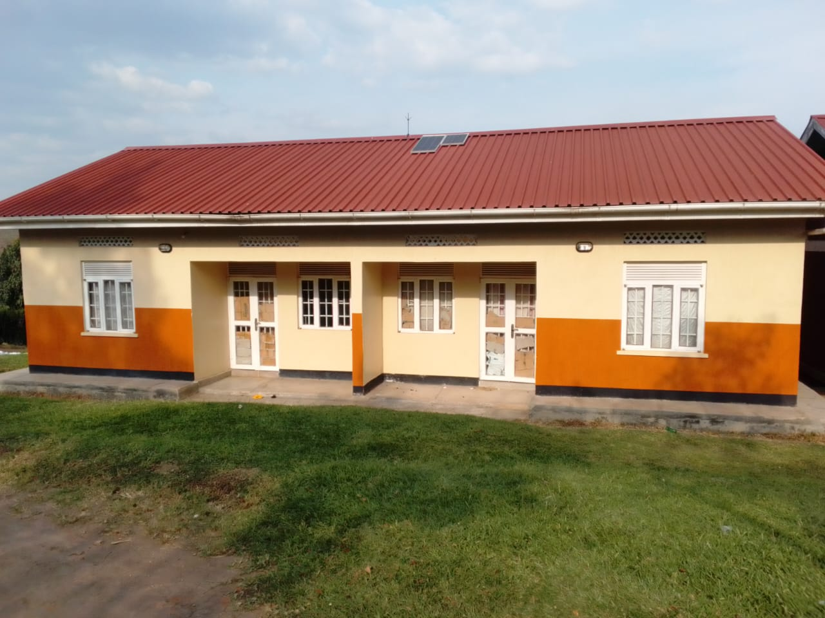
4 STANCE LINED PIT LATRINE | 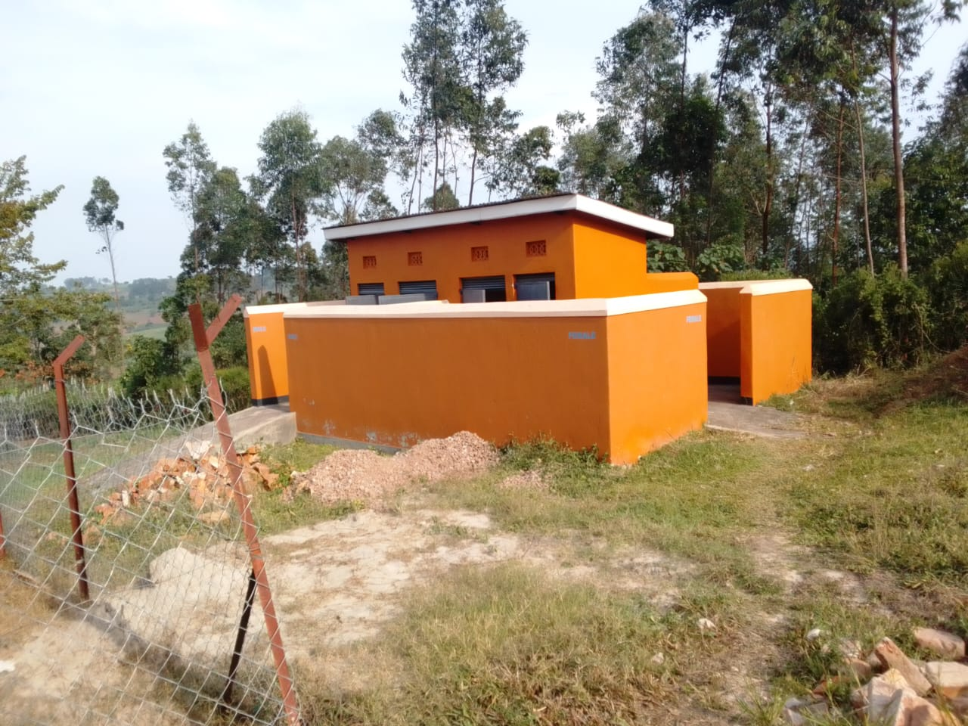
MATERNITY BUIL  DING WITH A WASTE PIT AND A PLACENTA PIT | 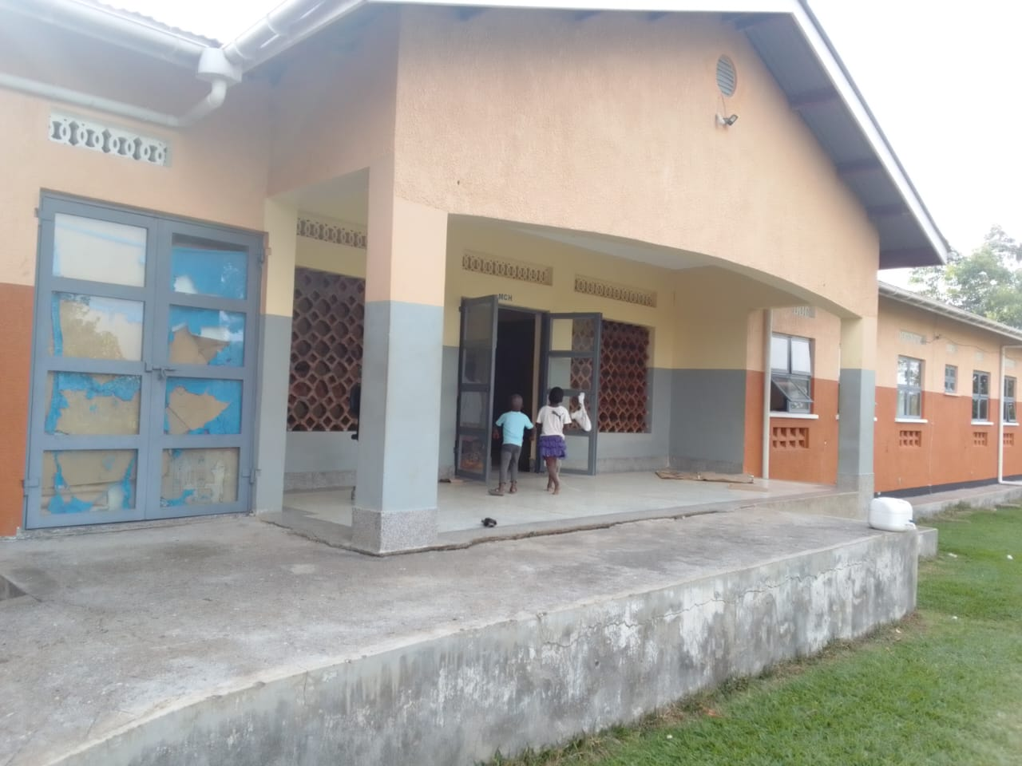
A FENCED SOLAR HOUSE, WITH BATTERIES | 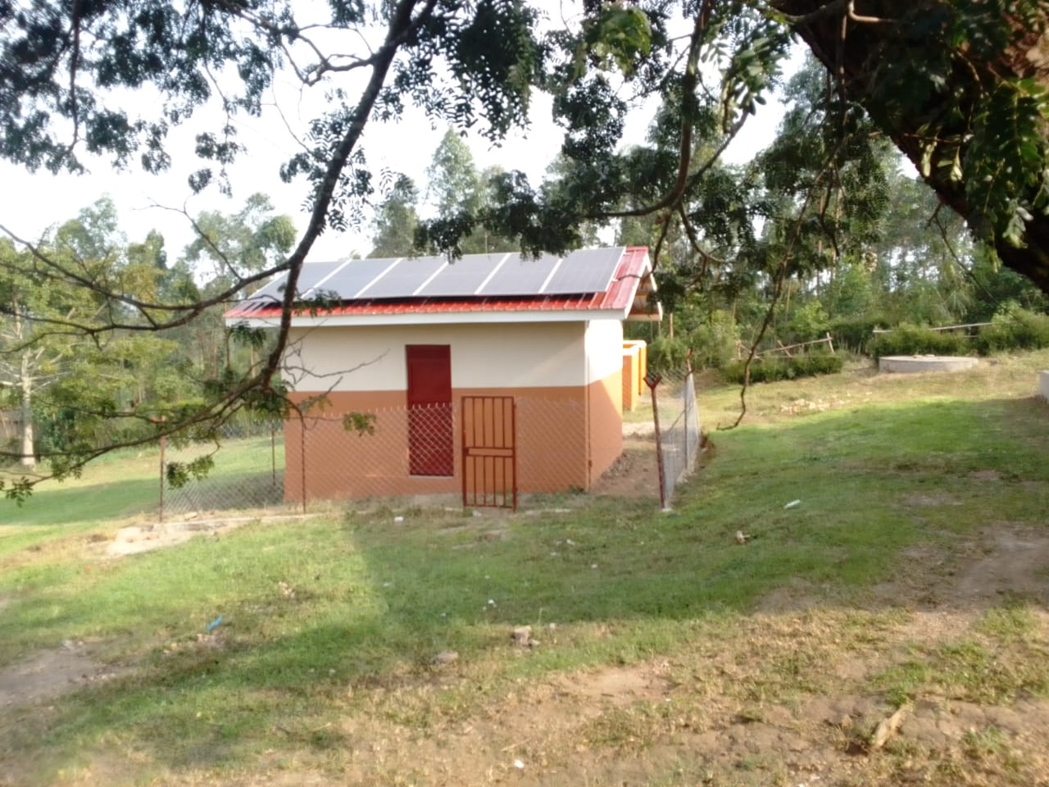
5,000LTRS HDPE CREST TANKS. | 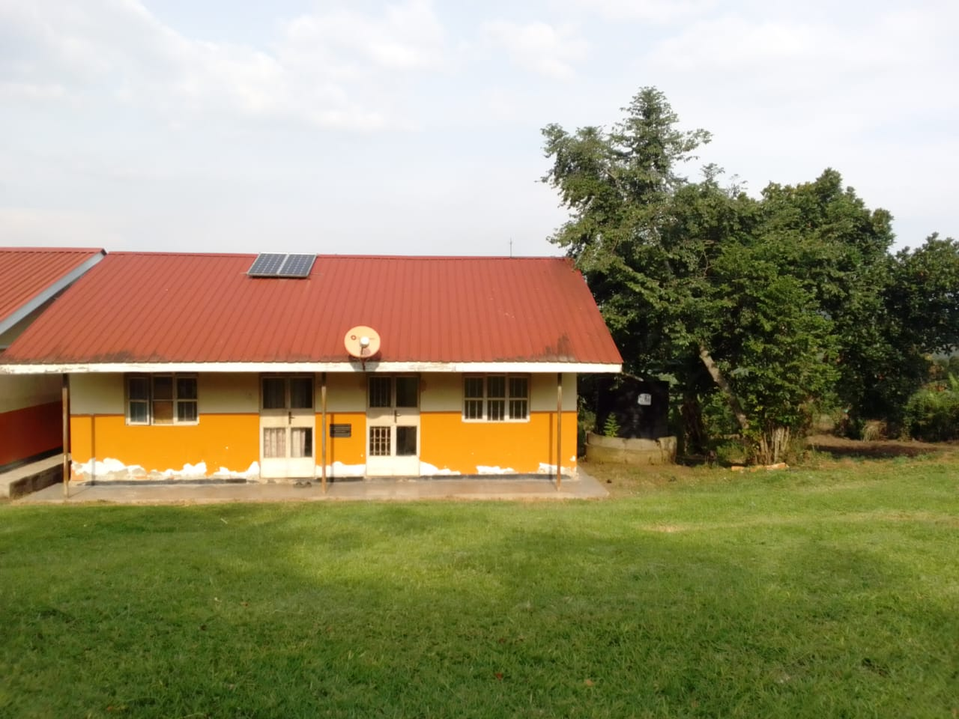
Disinfection bucket | 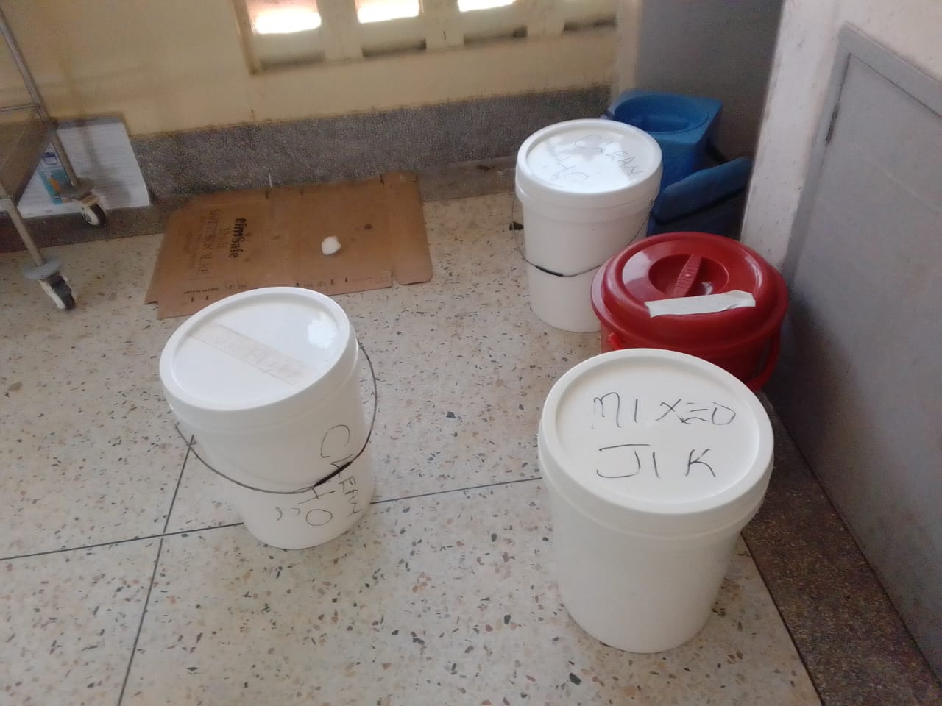
centrifuge | 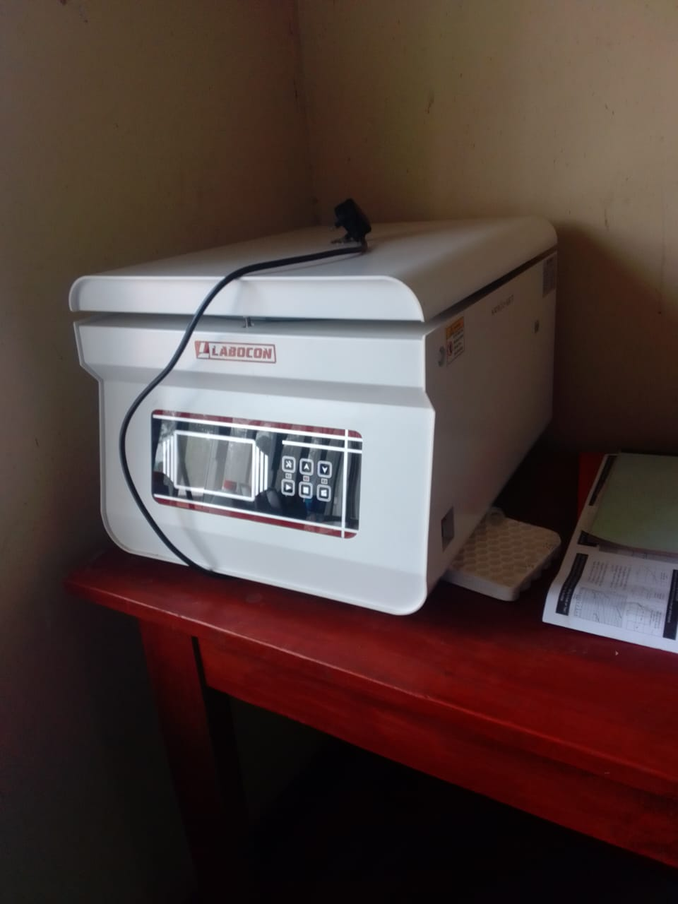
Weighing scale, toddler | 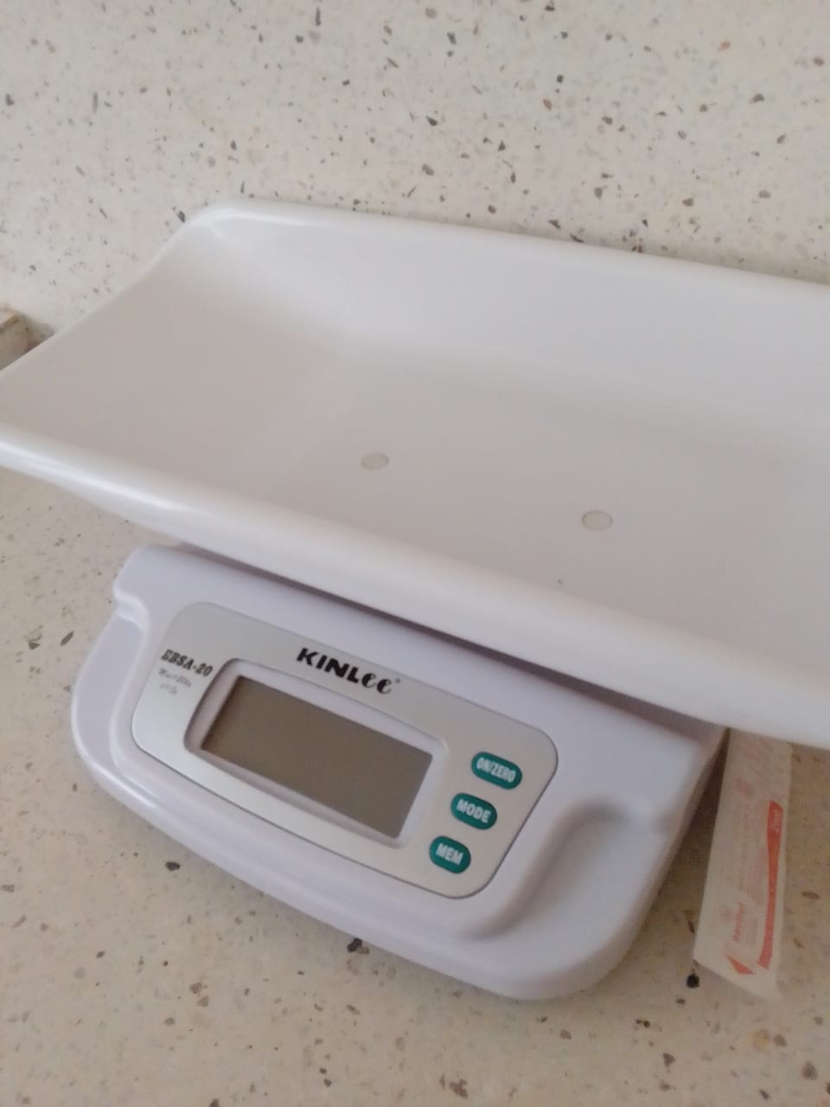
patient screen | 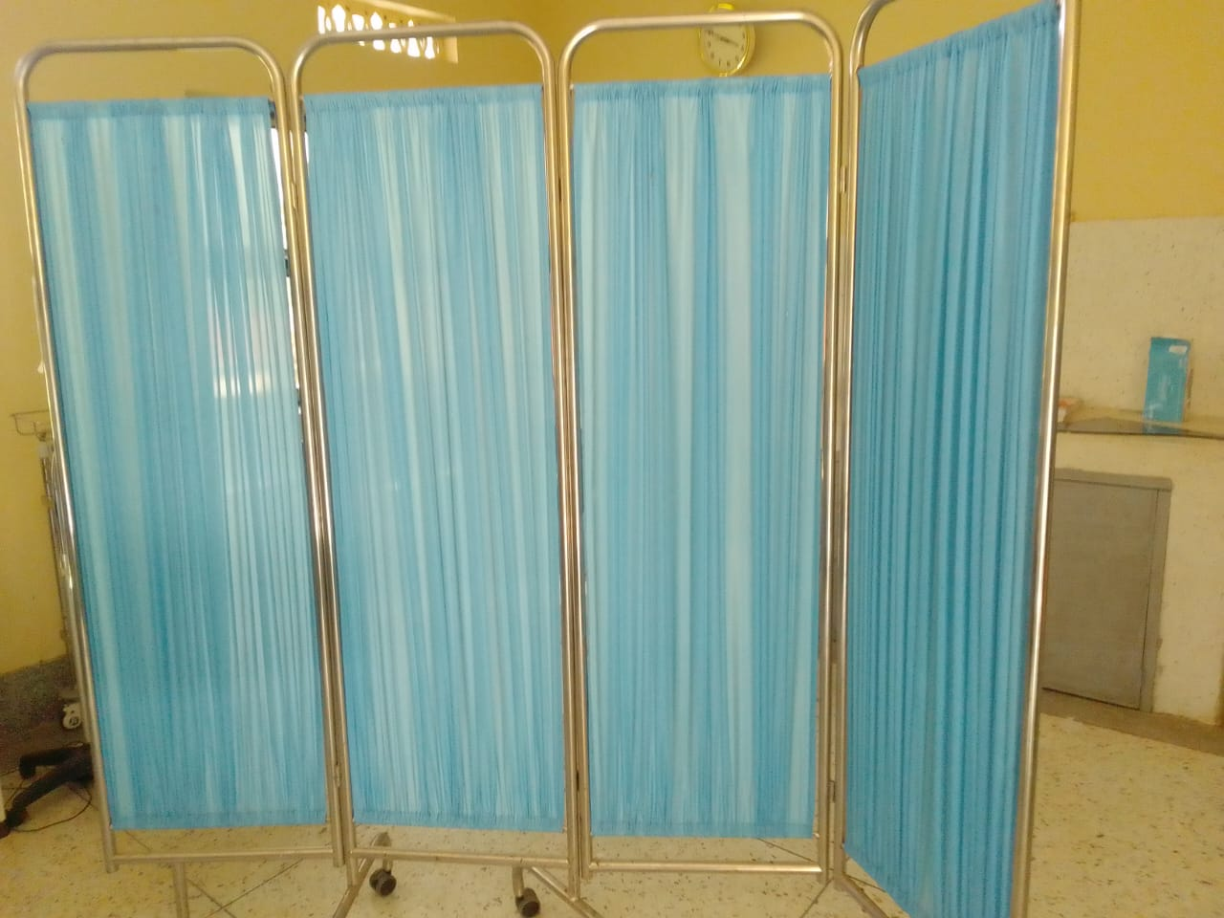
Delivery bed, hydraulic | 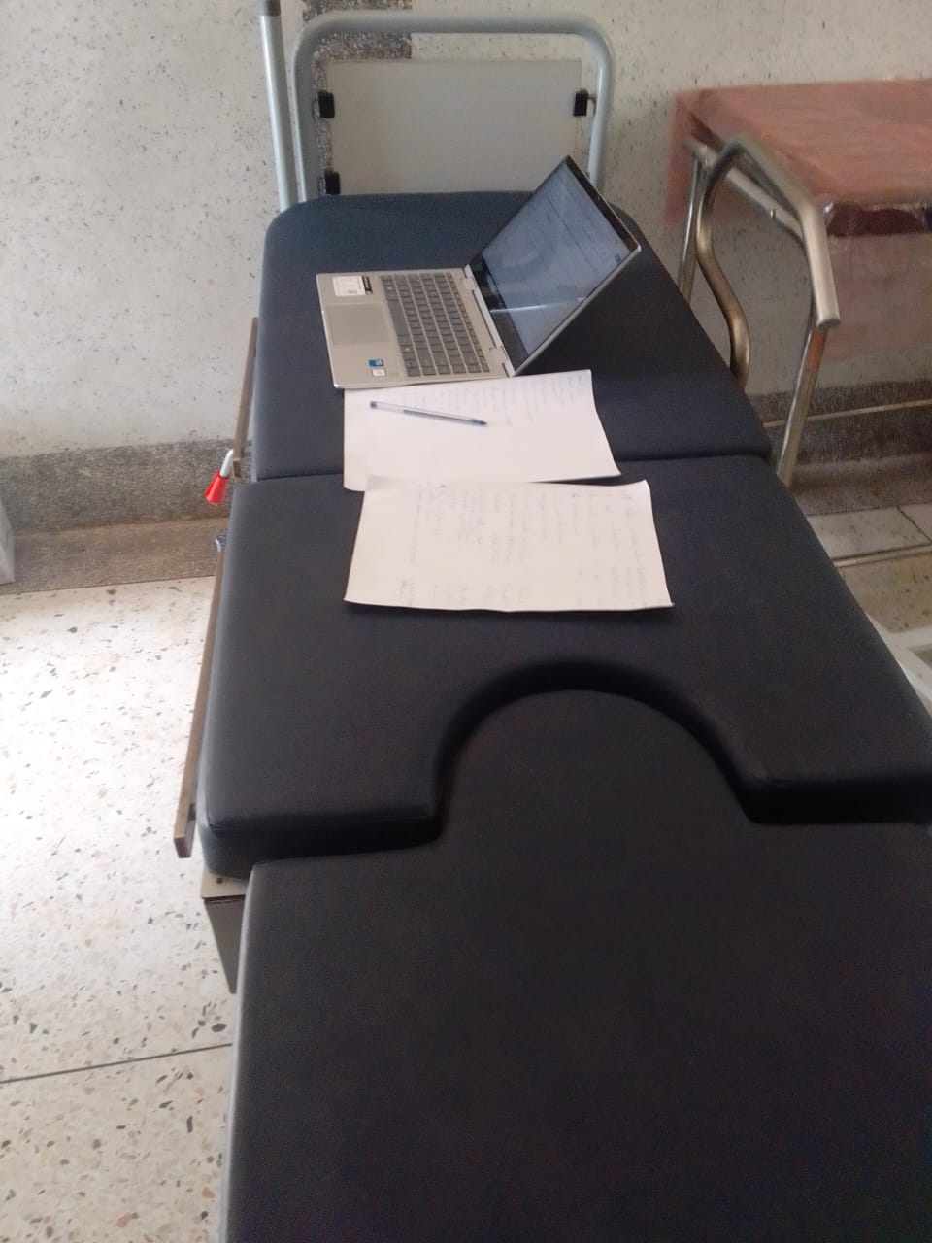
Diagnostic equipment set for OPD | 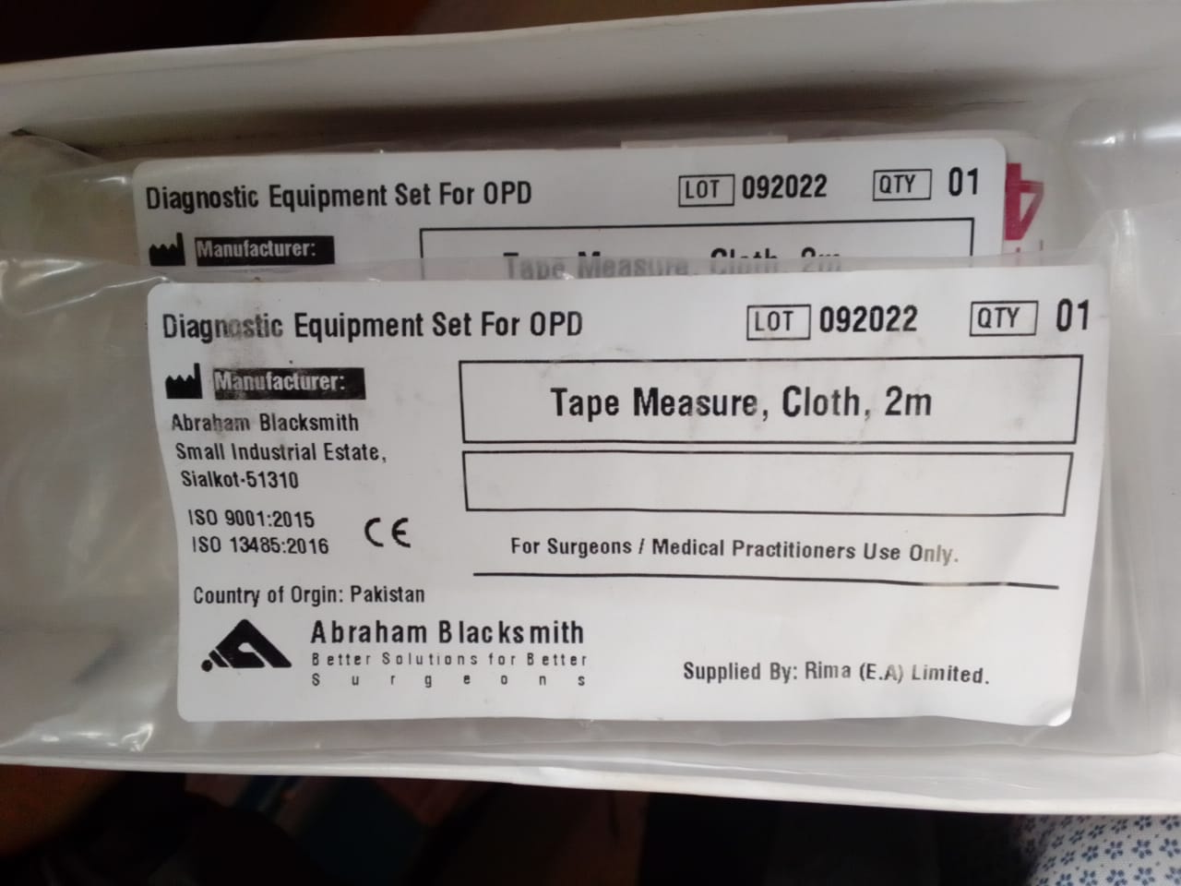
Examination light, LED and examination couch | 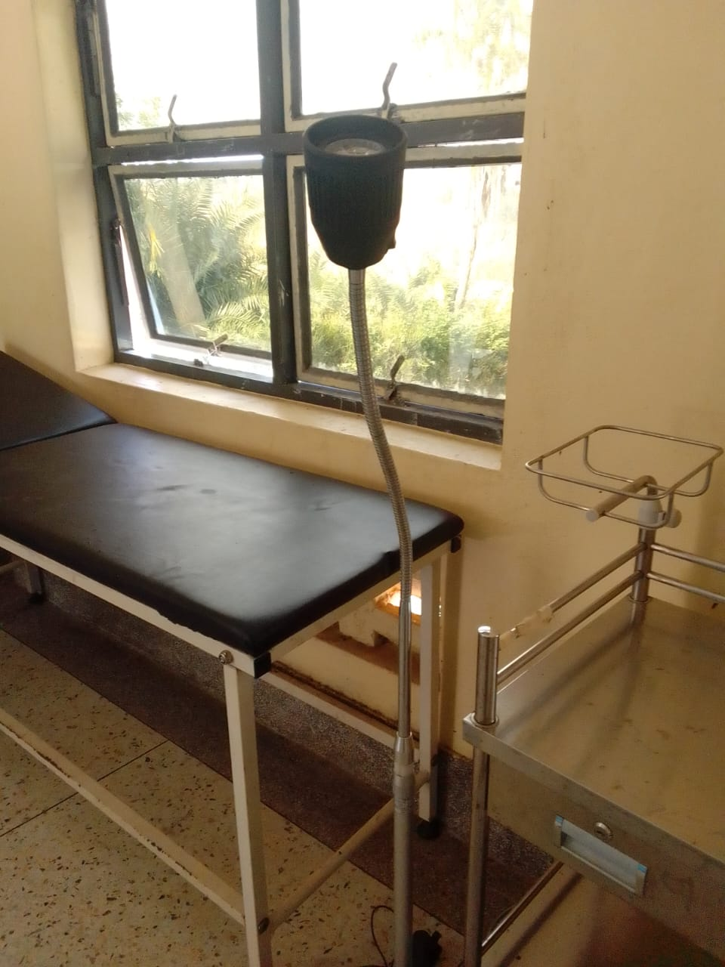
Oxygen concetrator | 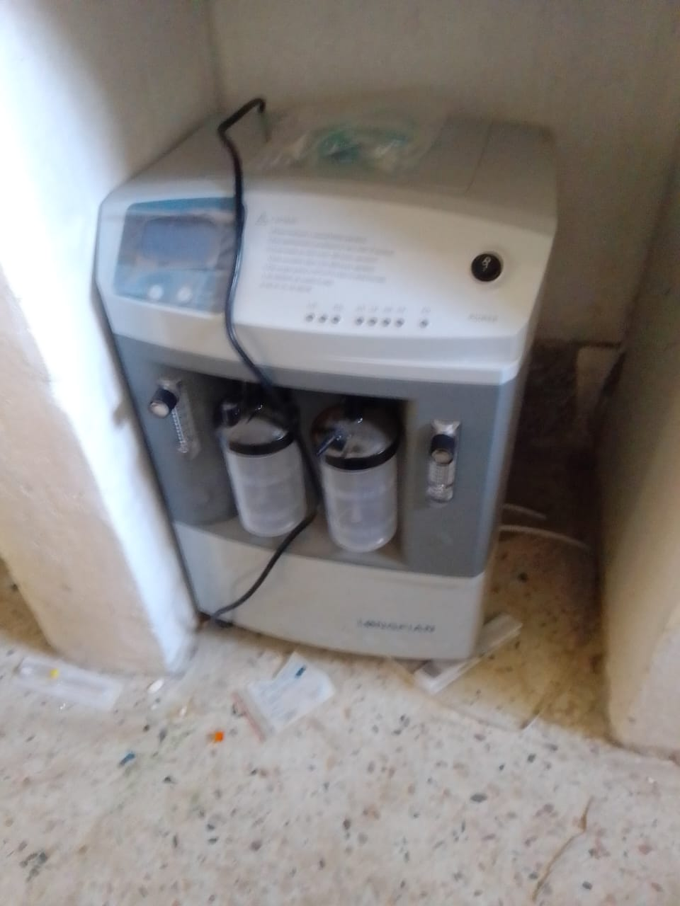
Patient trolly | 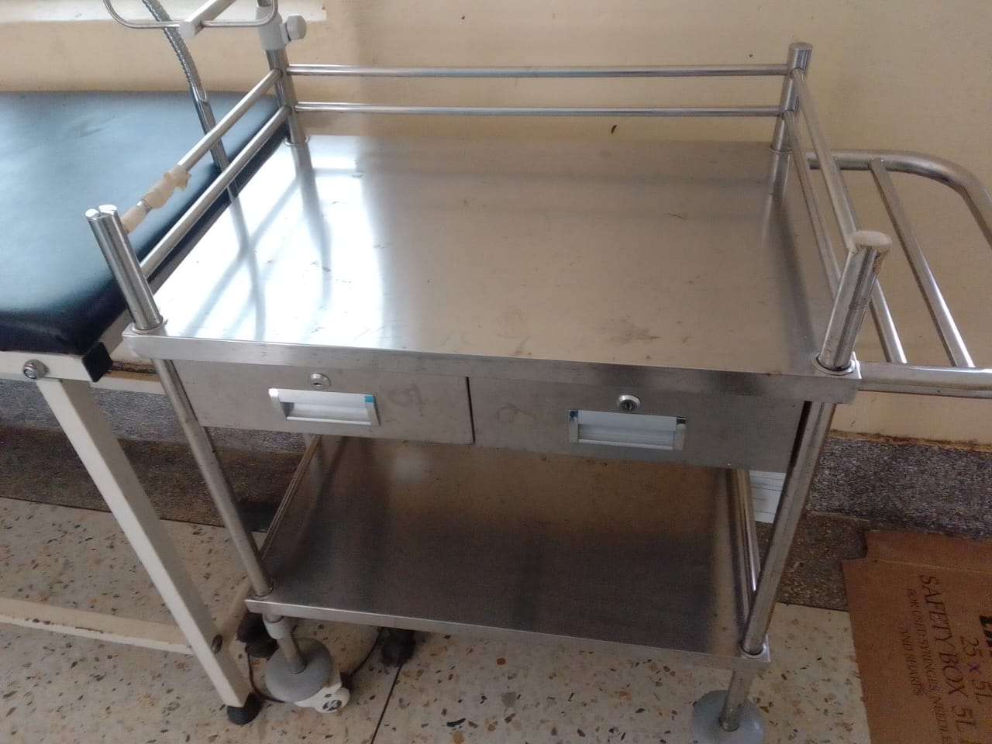
Sample of the patient beds that are engraved | 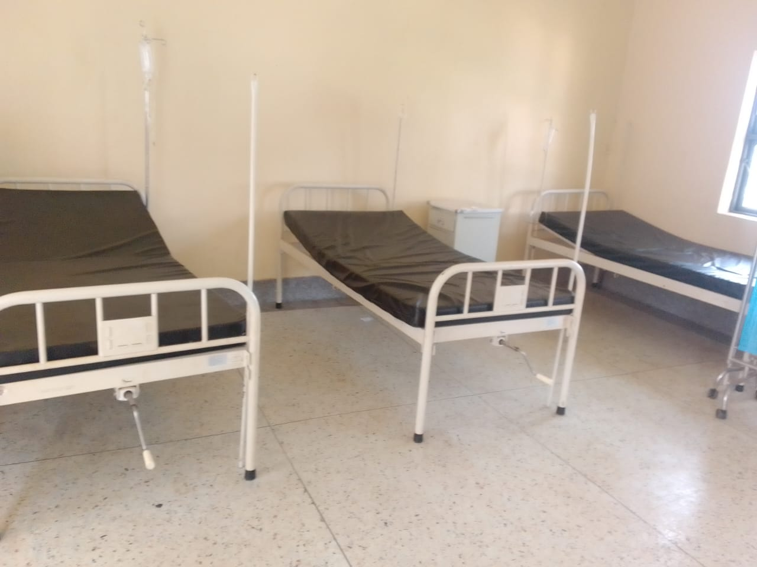
Pediatric beds with and bed side lockers | 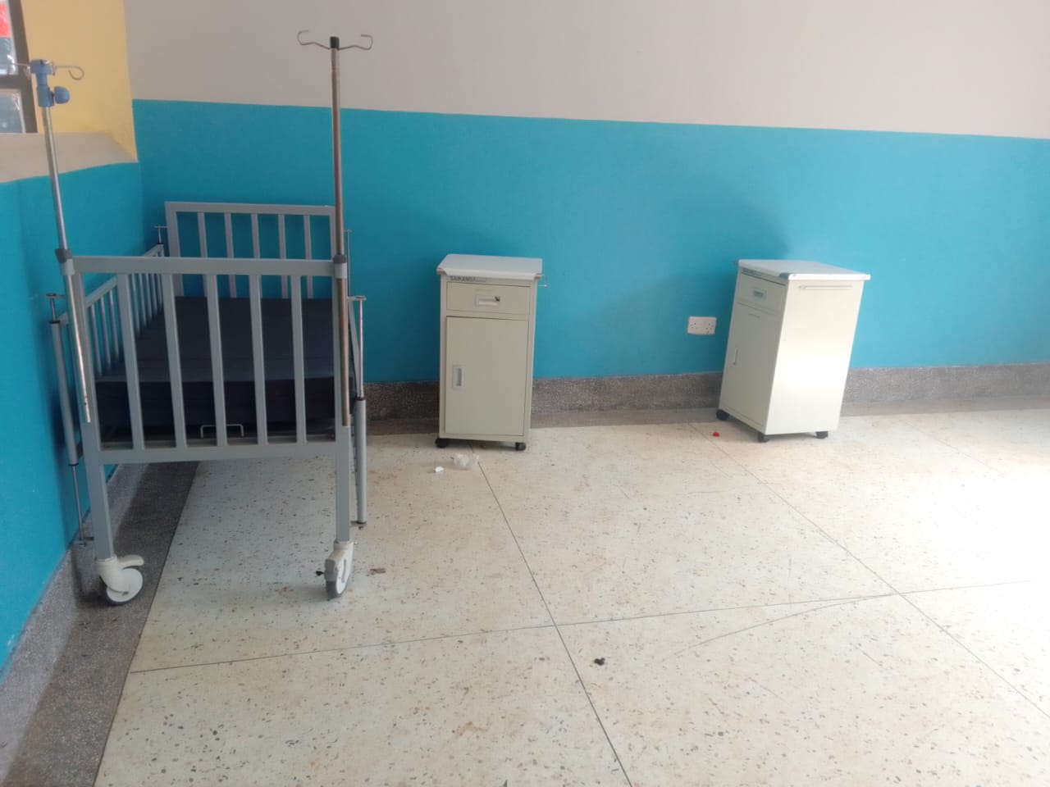
Kangaroo mother care chair | 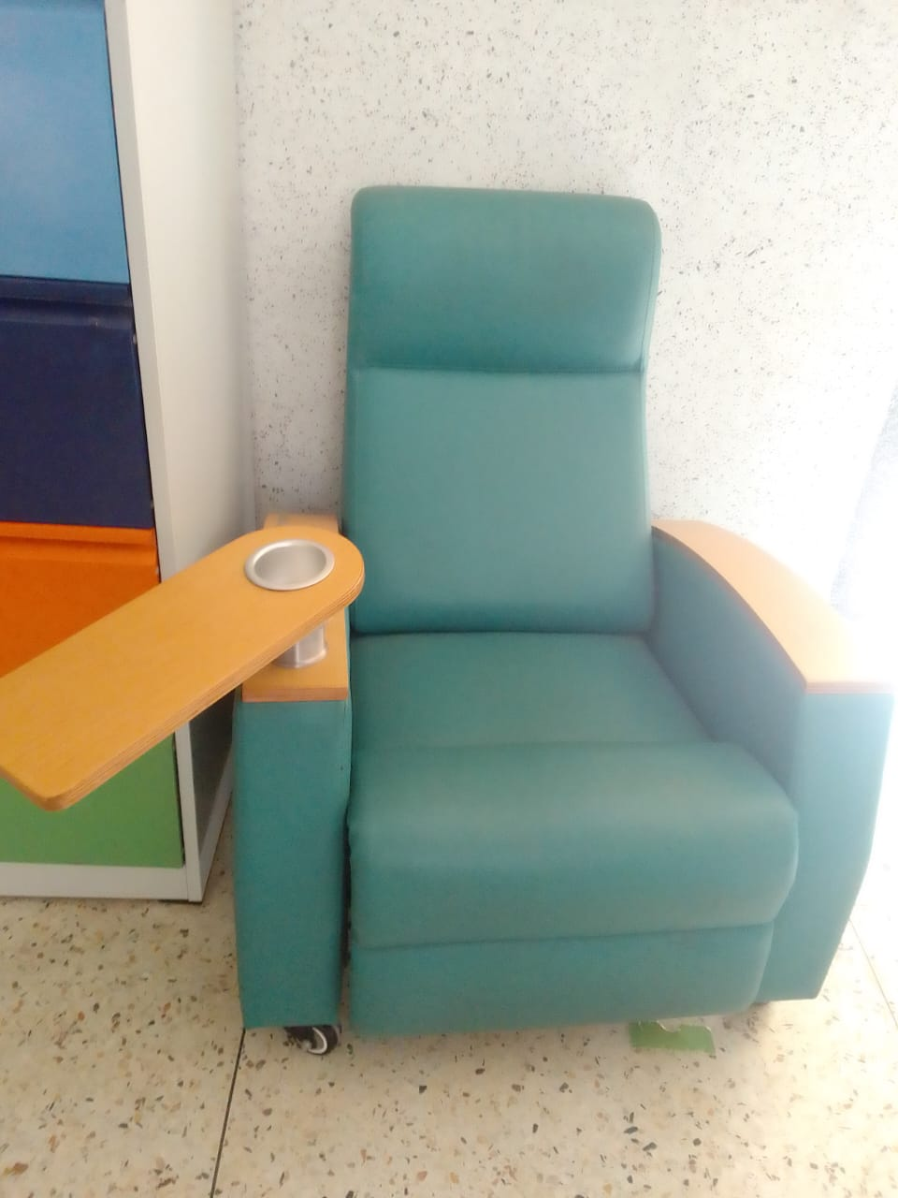
Wheelchair | 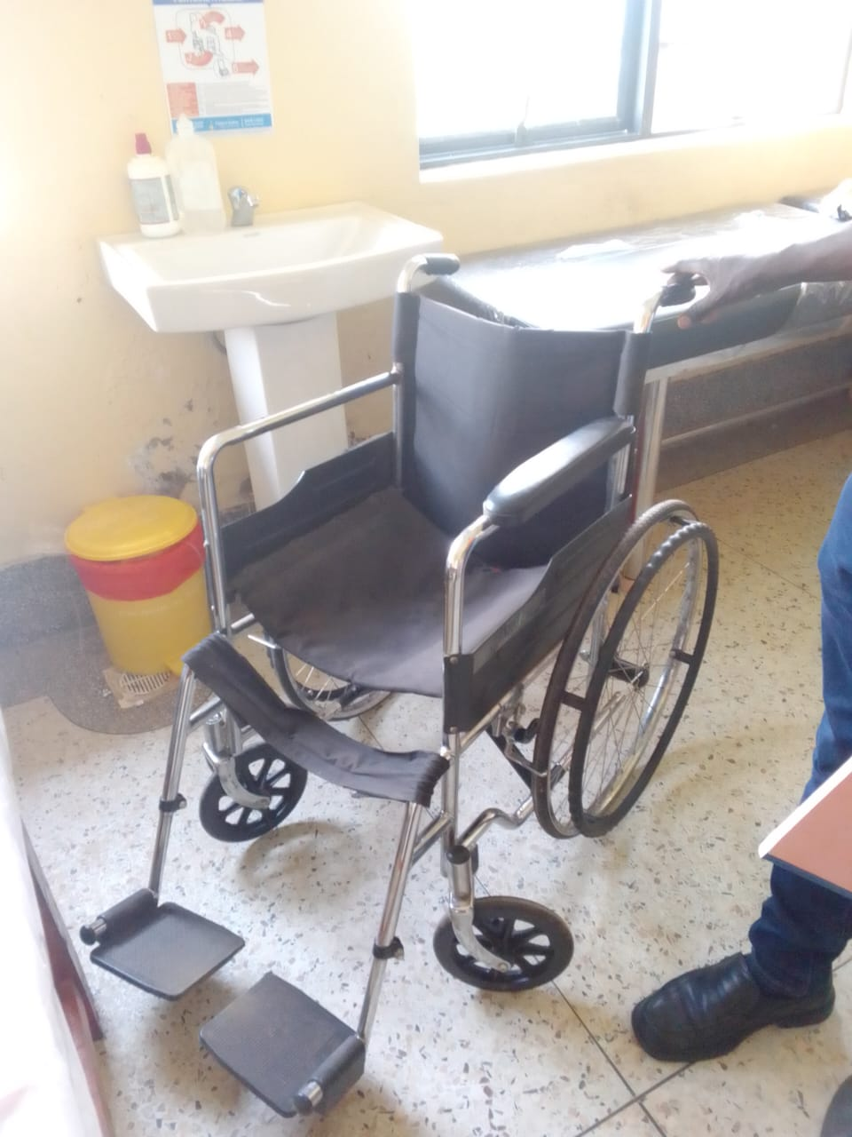
Instrument cupboard with glass | 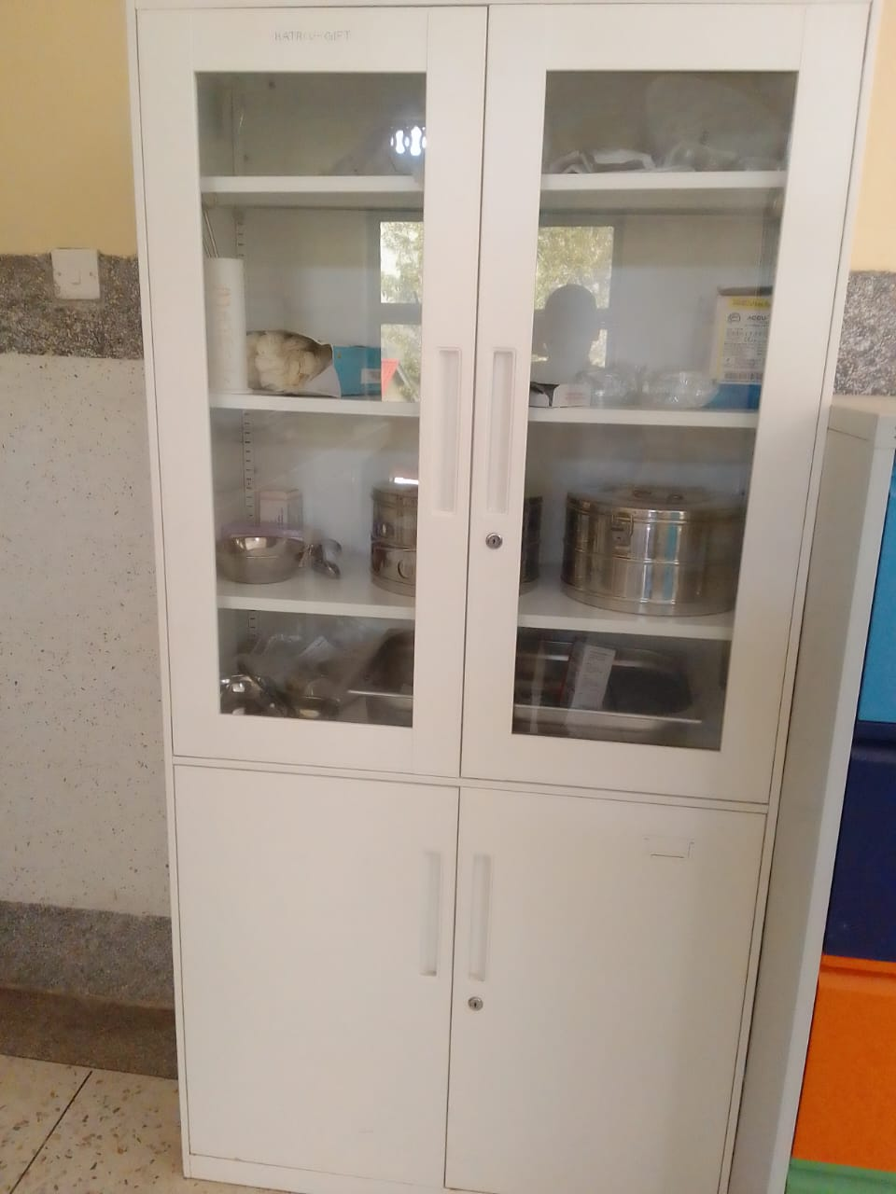
Sample of filling cabinet | 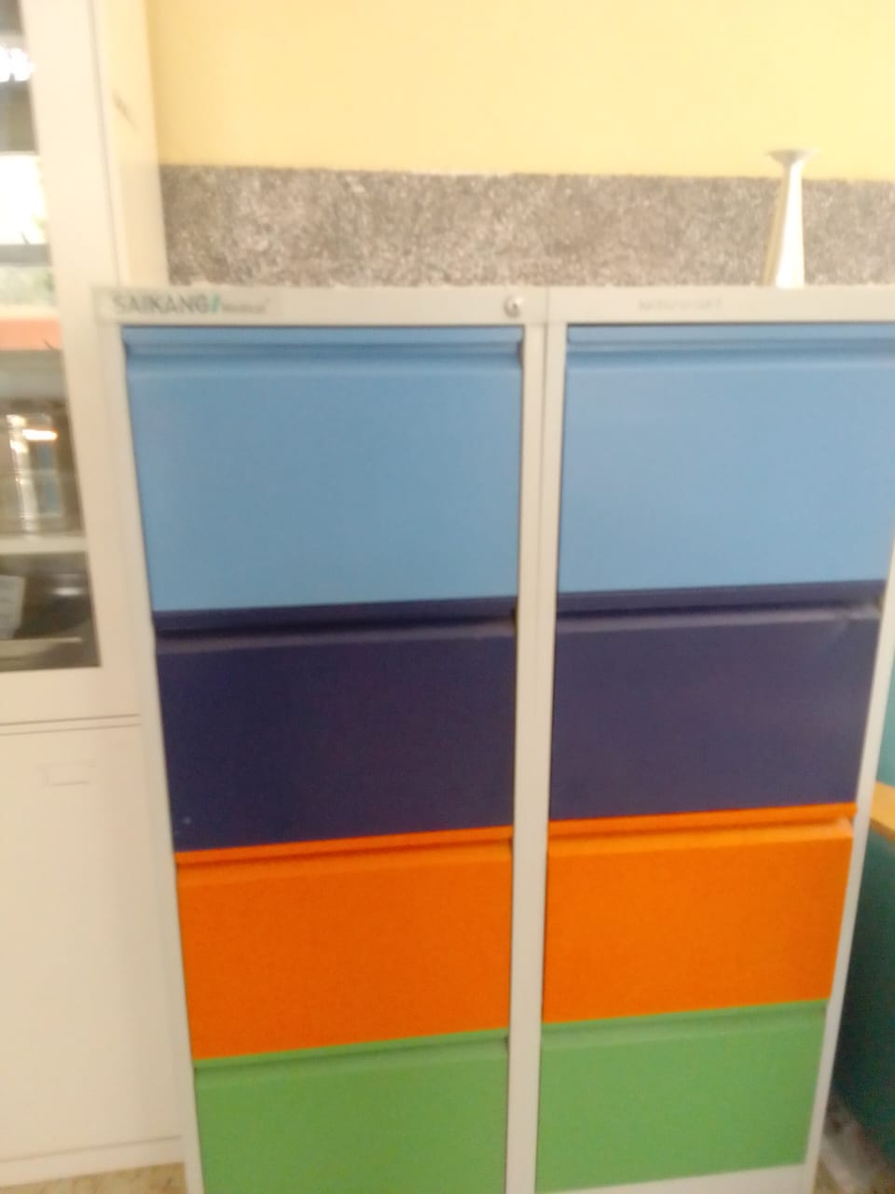
Autoclave duo operated | 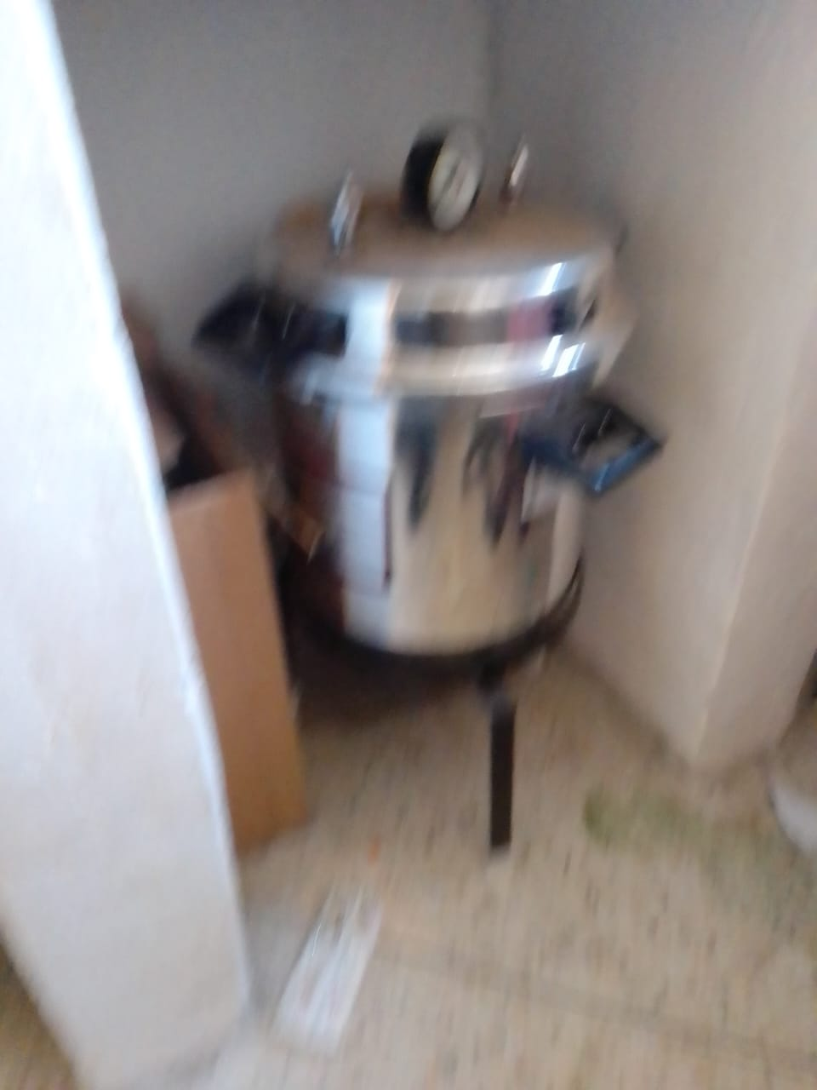
Sample of resuscitator, newborn- reusable | 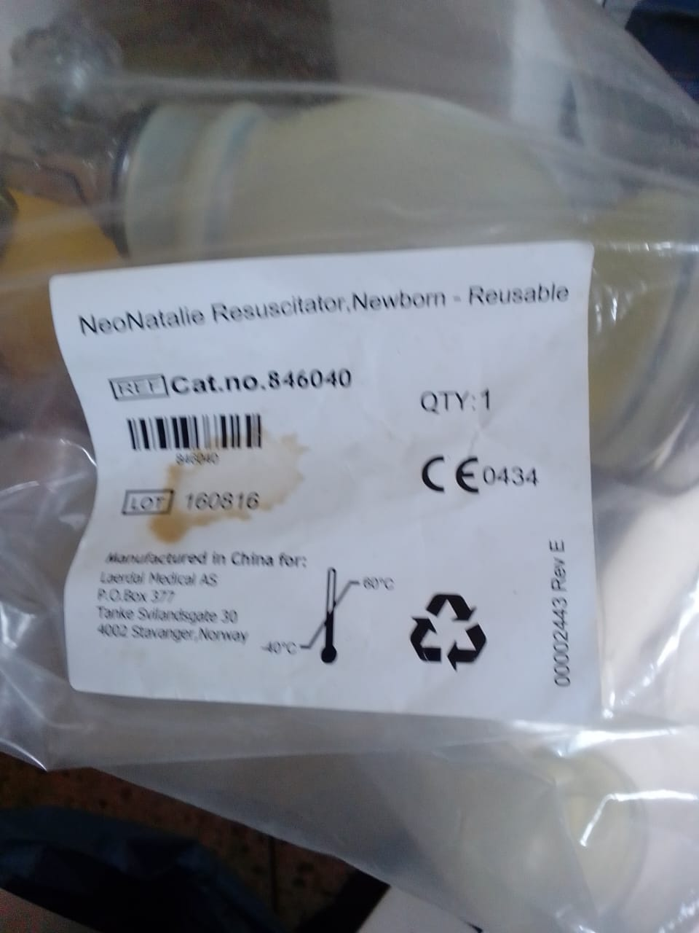
Sample of diagnostic sets for the ward | 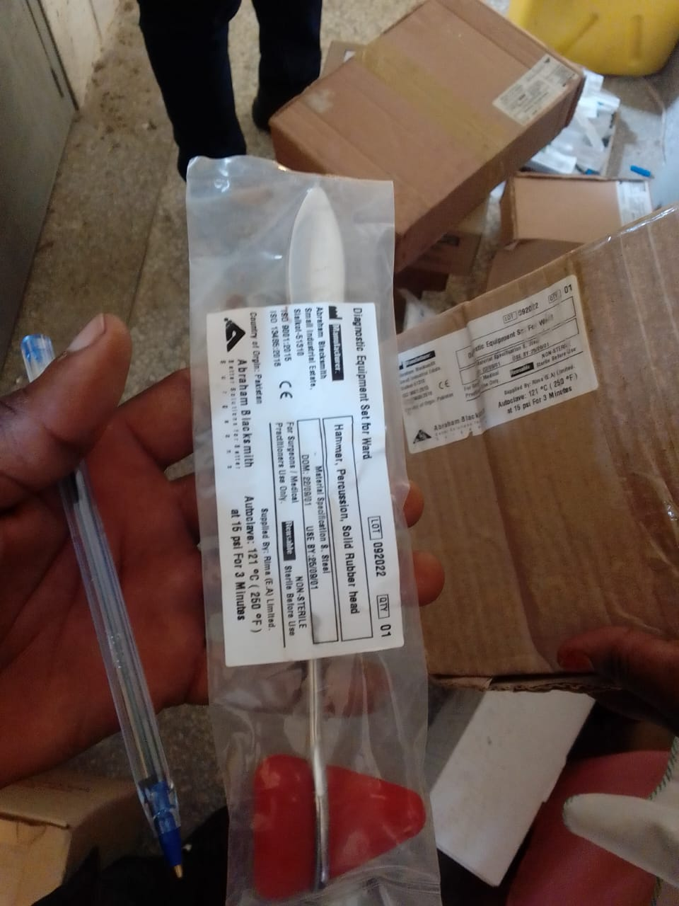
Sample glassware set, laboratory | 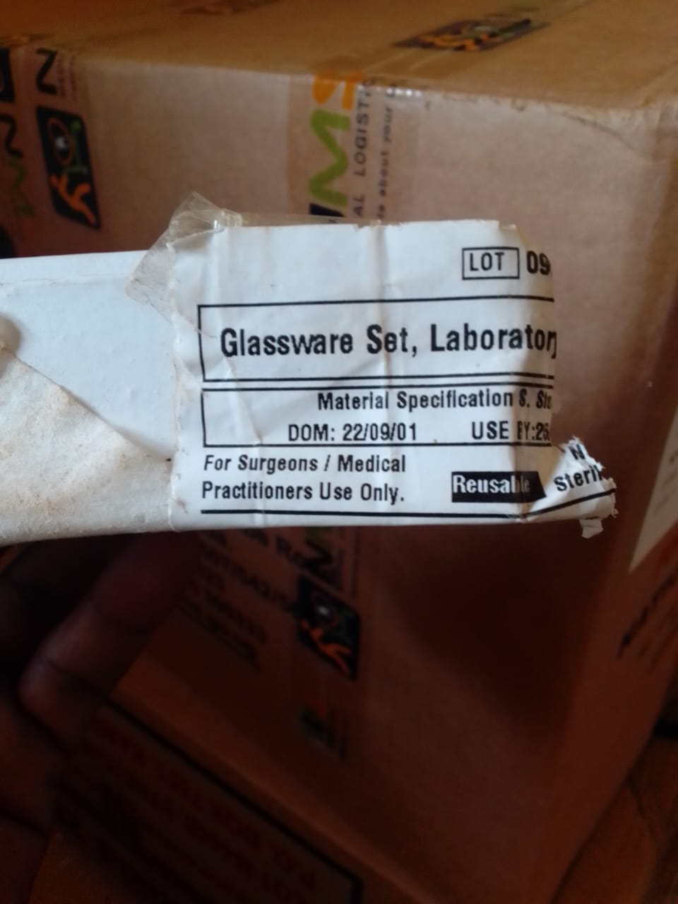
Sample of instrument set, stitch removing | 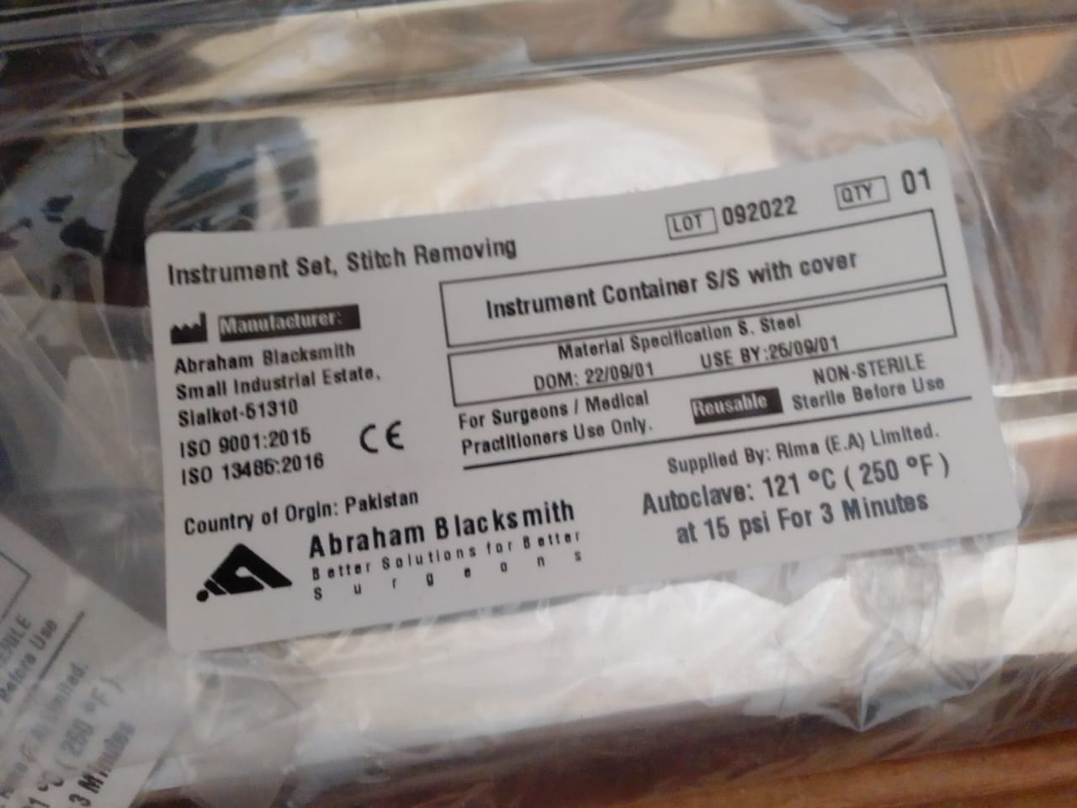
Stove, gas | 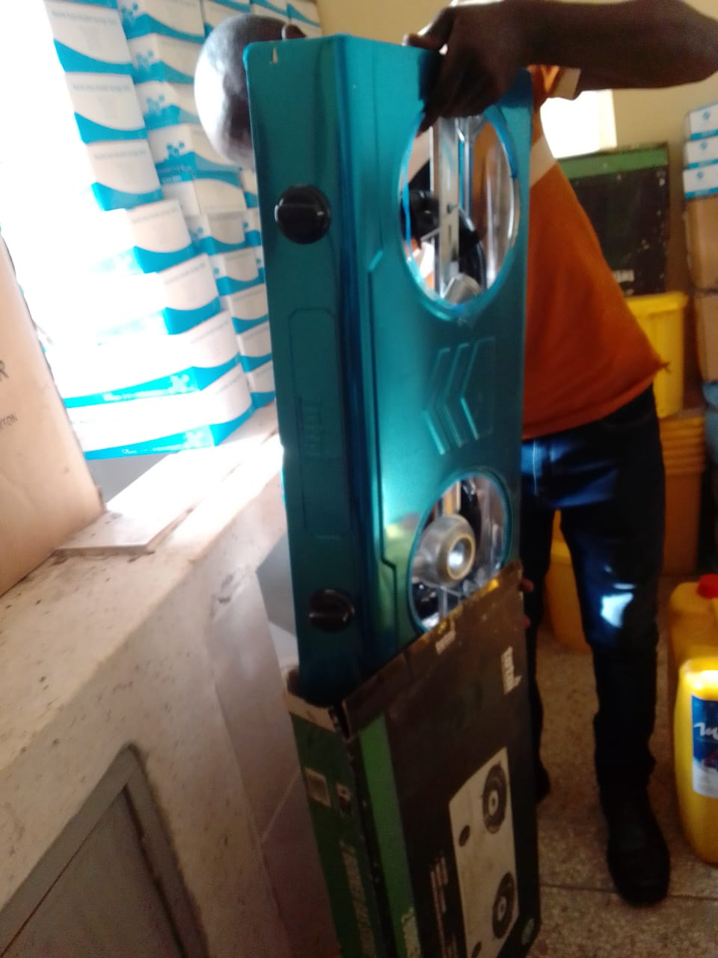
Stethoscope | 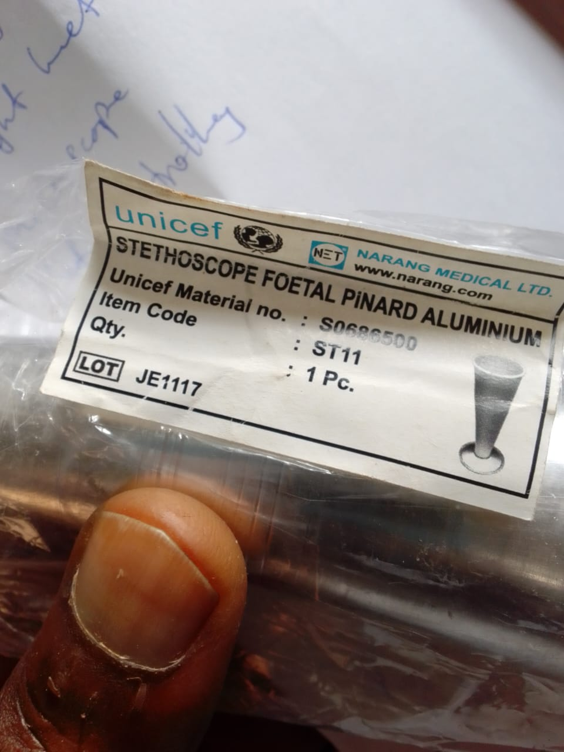
Penguin newborn suction | 